Parent’s Night Out Adjacent Programs in Georgia

Ready, Set, Fun! 6331 Roswell Road, Sandy Springs, GA 30328
https://readysetfun.com/parents-night-out/
You drop your kids off and we take care of them for a couple of hours—it’s that simple. The event hours are from 6 – 9 p.m. on special Fridays It’s open for children ages three and up, and those attending must be potty trained. $40 for the first child, and $30 for each additional child. Food is included! Kids will spend time in our playground, in addition to special activities and fun competitions like Dance, Yoga, Agility, and more! So come and join the FUN!
YMCA of Metro Atlanta 569 Martin Luther King Jr Drive NW Atlanta, GA 30314
https://ymcaatlanta.org/more-explore/parents-time-out
Programs are available for kids between ages 2 and 12. Registration opens up several weeks before each opportunity, so be sure to check schedules regularly. Space is limited and programs fill up quickly!
Autism Hope Center 727 54th Street Columbus, GA 31904
https://docs.google.com/forms/d/e/1FAIpQLSdfM0Q9NdUY-SU3BxqJB6N5f1FOngAYOkxQY1hzoCEA2cIkhw/viewform
The Autism Hope Center is offering, a once a month, free night out to parents of children with Autism, Developmental Disabilities and their siblings all over the age of 3.

Goal Point Behavior Group
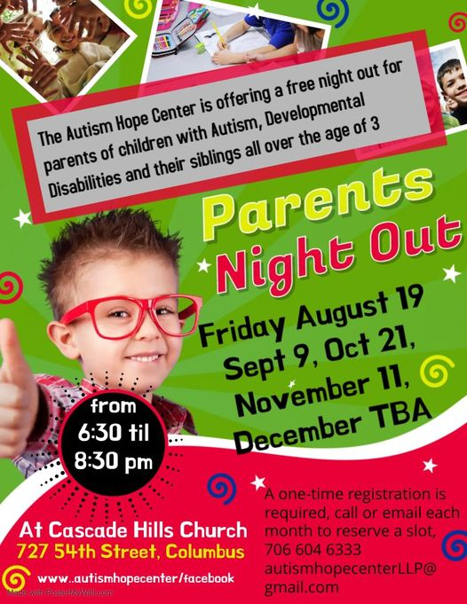

The Arc Macon 4664 Sheraton Drive Macon, GA 31210
https://thearcmacon.org/
Seasonal parties are held in partnership with the Macon/Bibb County Parks and Recreation Department-Adaptive Program. These include a Valentine Banquet and Dance ($10 per person), October Fall Jamboree ($5 per person), and Christmas Banquet and Dance ($10 per person). We also help sponsor a once-a-month aKtion club, which operates under the umbrella of Kiwanis International. Members follow the same guidelines as other Kiwanis clubs by paying dues, saying the Pledge of Allegiance, electing officers, and working on service projects.
The Arc Macon also provides Special Olympic training in Basketball Skills, Table Tennis, Softball, and Bocce’ Ball. A team is also sponsored to compete in the State Master’s Bowling Tournament. Look for updates and event postings on our website.

Eagle’s Nest Children’s Center 304 Pierce Ave Macon, GA 31204
https://www.themethodisthome.org/eagles-nest-childrens-center/
We strive to provide a nurturing environment where children ages 6 weeks through 4 years can receive developmentally appropriate care during the hours of 7:00 a.m. to 6:00 p.m. We are open Monday through Friday all year long.

FOCUS Atlanta, GA
https://focus-ga.org/program/family-activities/

Eligibility
- FOCUS Kid must be 29 and under at event date.
- Have a physical and/or developmental disabilities, including rare genetic syndromes, cerebral palsy, autism, and Down syndrome.
- Siblings 21 and under
- 2 parent/caregiver tickets per family

What makes FOCUS Family Acitivites Unique
- A day at Atlanta venues is a typical outing for a typical family. But a family with a child with disabilities might never consider such an outing; their child may not be able to spend the entire day to justify the cost of the tickets or they may shy away because of the stares of strangers.

Other Information
- Registration notifications are emailed out to all active FOCUS families in the Monday Parent email. If you think that you are an active FOCUS Family but you do not receive emails from us, please let us know.
- While fees are charged for activities, partial scholarships are available for SOME activities. Partial scholarships are awarded based on financial need.
- 3rd Party Waivers are NOT accepted for Family Activities.
- Cancelation: FOCUS will refund your event fee, minus the deposit fee for all cancellations made two weeks prior to the date of the event. Any cancelation within two weeks of event date will receive no refund.
- Registration required.

Annual FOCUS Events
Valentine’s Day Party | February 12th
Six Flags | May 21st
Boo-B-Que | October 14th
Aquarium | September 17th
Brunch with Santa (for Medically Fragile Families only) | Coming Soon
FOCUS + Lekotek Holiday Party | December 10th, 2022
Special Needs Respite Roswell, GA
https://www.specialneedsrespite.org/

Special Needs Respite helps bridge the existing funding gap that many parents have when trying to get childcare for their special needs child. We can provide funds that will pay qualified caregivers to care for these children when no other way to pay is available to the parents.

Macon Milestones Macon, GA
https://www.maconmilestones.com/respite-care.html
Asking for help isn't always easy, but taking care of your family includes taking care of yourself. Our in home care service provides short-term care and supervision to parents who need an extra hand or respite during emotional and physical overwhelming times. As a parent raising a child with a disability, you might find that "me time" is more fantasy than reality. Let us help ease the tension and stress that can be damaging to your own health. Parents can spend time on a hobby, get a massage, or go grocery shopping.
​In-home respite care for children with disabilities also allows parents to focus on other children and family members as well as providing extra time and help to complete tasks that need to get done. To schedule a Free in-home assessment and discuss options contact us today!
There are several churches throughout our area that provide respite DURING church services:
See list…

